**Lesson 5 Demo 3**

**Understanding DaemonSet**

**Objective:**  Understanding the DaemonSet

**Tools required:** kubeadm, kubectl, kubelet, and etcd

**Prerequisites:** kubeadm, kubectl, kubelet, and etcd should be installed

Steps to be followed:

1. Creating a DaemonSet
2. Verifying the DaemonSet

**Step 1: Creating a DaemonSet**

* 1. Create a **daemonset.yaml** file using the following command:

**vi daemonset.yaml**

* 1. Copy and paste the below code in **daemonset.yaml** to create a DaemonSet:

**apiVersion: apps/v1**

**kind: DaemonSet**

**metadata:**

**name: frontend**

**spec:**

**selector:**

**matchLabels:**

**name: frontend-webserver**

**template:**

**metadata:**

**labels:**

**name: frontend-webserver**

**spec:**

**containers:**

**- name: webserver**

**image: httpd**

**ports:**

**- containerPort: 80**

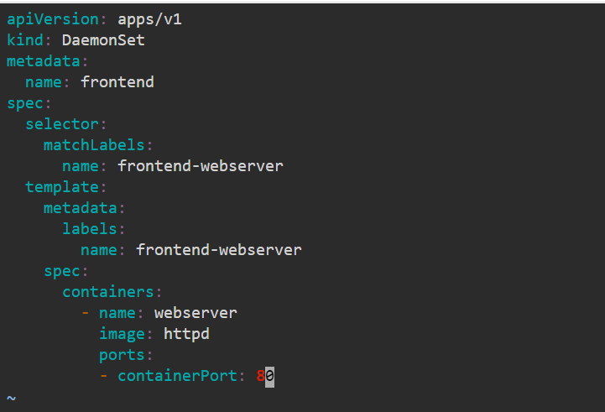

* 1. Create a DaemonSet by using the following command:

**kubectl create -f daemonset.yaml**

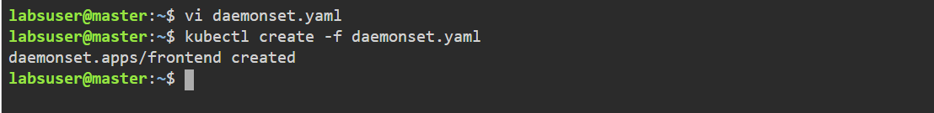

**Step 2: Verifying the DaemonSet**

2.1 Verify the DaemonSet state by using the following command:

**kubectl get ds**

